Capstone Project Design Document

Phase 1 – Requirements and Scope
1. Project overview
Event-Driven Order Processing System is a Spring Boot application composed of two services:
- Order Service – accepts orders, stores them and updates their status.
- Fulfilment Service – consumes order events, processes fulfilment and publishes the outcome.
The services communicate asynchronously through Apache Kafka. Each service uses an H2 in-memory database to keep the project lightweight and allow the capstone to focus on clean code, testing and event-driven architecture.
2. Figure 1 – High-Level Event-Driven Order Processing Flow
Figure 1 illustrates the high-level event-driven architecture of the proposed system. The Order Service receives synchronous REST requests from the client, validates and stores the order in its own H2 in-memory database before publishing an OrderCreatedEvent to Apache Kafka. The Fulfilment Service consumes the event, processes the order and stores the fulfilment result in its own H2 in-memory database before publishing either an OrderFulfilledEvent or an OrderRejectedEvent back to Kafka.
The Order Service then consumes the resulting event and updates the status of the original order in its own database. Although the diagram repeats the Order Service and its database to illustrate the sequence of processing, these represent the same service and database, not additional components. Separate databases were chosen to reflect the microservice principle that each service owns and manages its own data independently.
H2 in-memory databases were selected to simplify development and testing while allowing the project to focus on Spring Boot, event-driven communication, clean object-oriented design and automated testing.
High-Level Event-Driven Order Processing Flow Diagram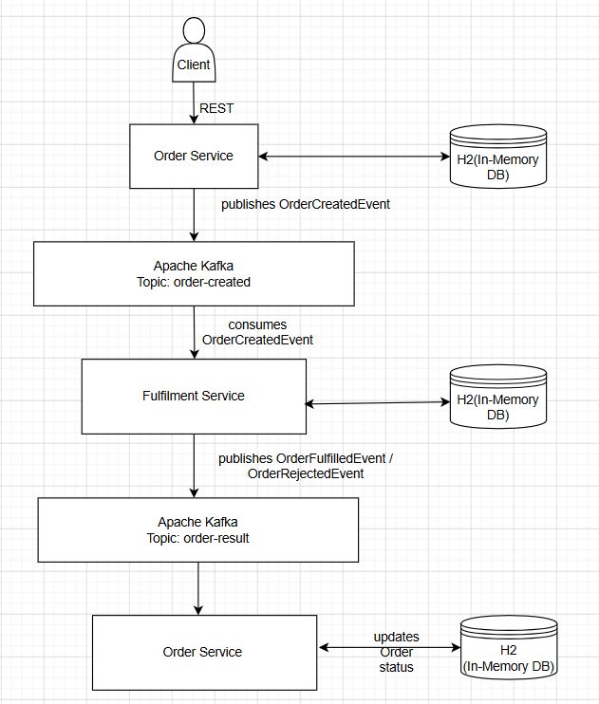

3. Figure 2 – UML Use Case Diagram
Figure 2 illustrates the interactions between the external client and the Event-Driven Order Processing System. The client can create a new order, retrieve an individual order and view all orders through the system's REST API. Internal activities such as Kafka messaging, fulfilment processing and database operations are intentionally omitted because they represent implementation details rather than user interactions.
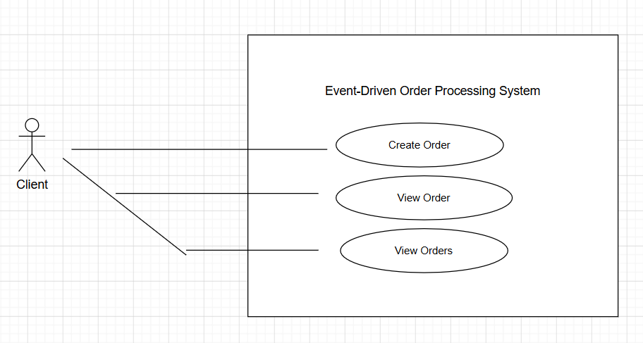

4. Figure 3 – UML Class Diagram
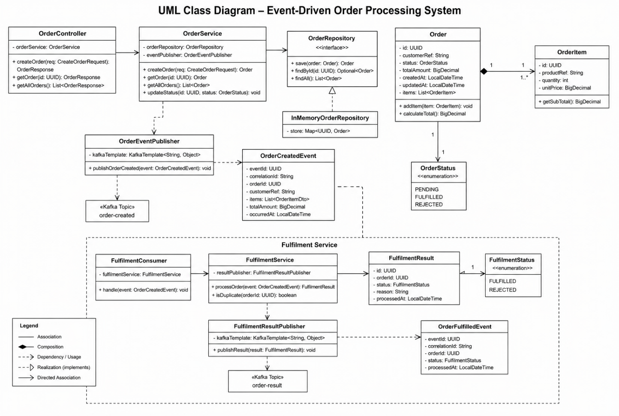

5. Functional requirements
FR1 – Create an order
The client shall be able to submit a new order through a REST endpoint.
The request shall contain:
- customer reference
- one or more order items
- product reference
- quantity
- unit price
FR2 – Validate an order
The Order Service shall reject an order when:
- the customer reference is missing
- no order items are supplied
- quantity is zero or negative
- unit price is zero or negative
- required fields are blank
FR3 – Store an order
The Order Service shall store a valid order in its H2 database with an initial status of:
PENDING
FR4 – Publish an order-created event
After the order has been stored, the Order Service shall publish an OrderCreatedEvent to the Kafka topic:
order-created
The event shall contain at least:
- event ID
- order ID
- customer reference
- order items
- total value
- event timestamp
- correlation ID
FR5 – Consume the order-created event
The Fulfilment Service shall consume OrderCreatedEvent messages from the order-created topic.
FR6 – Process fulfilment
The Fulfilment Service shall decide whether the order can be fulfilled.
For the first version, the decision may be based on a simple rule, such as:
total order quantity must not exceed 20 items
This keeps the logic predictable and easy to test.
FR7 – Store fulfilment results
The Fulfilment Service shall store the processing result in its H2 database.
The result shall include:
- event ID
- order ID
- fulfilment status
- reason for rejection, when applicable
- processed timestamp
FR8 – Publish the fulfilment outcome
The Fulfilment Service shall publish either:
OrderFulfilledEvent
or:
OrderRejectedEvent
to the Kafka topic:
order-result
FR9 – Consume the result event
The Order Service shall consume result events from the order-result topic.
FR10 – Update order status
The Order Service shall update the order status to:
FULFILLED
or:
REJECTED
FR11 – Retrieve an order
The client shall be able to retrieve an order by its ID through a REST endpoint.
Example:
GET /api/orders/{orderId}
FR12 – List orders
The client shall be able to retrieve all orders.
Example:
GET /api/orders

6. Non-functional requirements
NFR1 – Maintainability
The system shall use clear package boundaries and separation of concerns between:
- controllers
- application services
- domain objects
- repositories
- Kafka producers
- Kafka consumers
- configuration
- exception handling
NFR2 – Testability
Business logic shall be testable independently of Kafka, the database and the web layer.
Dependencies shall be injected through constructors so they can be mocked during unit testing.
NFR3 – Reliability
The system shall handle consumer failures using retry behaviour and a dead-letter topic.
NFR4 – Idempotency
The Fulfilment Service shall detect duplicate events and prevent the same order from being processed more than once.
NFR5 – Traceability
Every event shall include:
eventId
correlationId
occurredAt
This allows an order to be traced across both services.
NFR6 – Validation
All external input shall be validated before it reaches the business logic.
NFR7 – Error handling
The REST API shall return clear and consistent error responses for:
- invalid requests
- missing orders
- unexpected failures
NFR8 – Performance
The REST API should respond quickly after storing the order and publishing the event, without waiting for fulfilment to finish.
NFR9 – Scalability
The services shall be loosely coupled so that Kafka consumers could be scaled independently in a larger deployment.
NFR10 – Portability
The project shall run locally using:
- Java 21
- Spring Boot
- Gradle
- Kafka through Docker
- H2 in-memory databases
NFR11 – Observability
The system shall expose Spring Boot Actuator endpoints and use meaningful application logs for order and event processing.
NFR12 – Clean code
The implementation shall use:
- meaningful names
- small focused methods
- single-responsibility classes
- interfaces where abstraction is valuable
- minimal duplication
- consistent exception handling

7. Assumptions
- Authentication is outside the initial project scope.
- Payment processing is not included.
- Inventory is represented by a simple fulfilment rule rather than a full stock-management system.
- H2 data is reset whenever the application restarts.
- Kafka runs locally through Docker.
- The client may initially be Postman or Swagger rather than a frontend.
- The project uses two Spring Boot services only.

8. Constraints
- The laptop has 8 GB RAM.
- Kafka must remain a single lightweight broker.
- PostgreSQL will not be installed.
- Kubernetes, service discovery and service mesh are outside scope.
- The system must remain small enough to complete within the assignment deadline.
- The design should prioritise clean code, testing, Spring Boot and EDA over infrastructure complexity.
9. Out of scope
To prevent the capstone becoming too large, exclude:
- user registration and login
- real payment gateways
- email or SMS delivery
- a React frontend
- cloud deployment
- Kubernetes
- advanced inventory management
- multiple Kafka brokers
- distributed tracing platforms
- production-grade database clustering
10. Success criteria
The capstone will be considered successful when this flow works end to end:
POST /api/orders
→ order stored as PENDING
→ OrderCreatedEvent published
→ Fulfilment Service consumes event
→ fulfilment result stored
→ OrderFulfilledEvent or OrderRejectedEvent published
→ Order Service consumes result
→ order status updated
→ GET /api/orders/{id} returns final status

